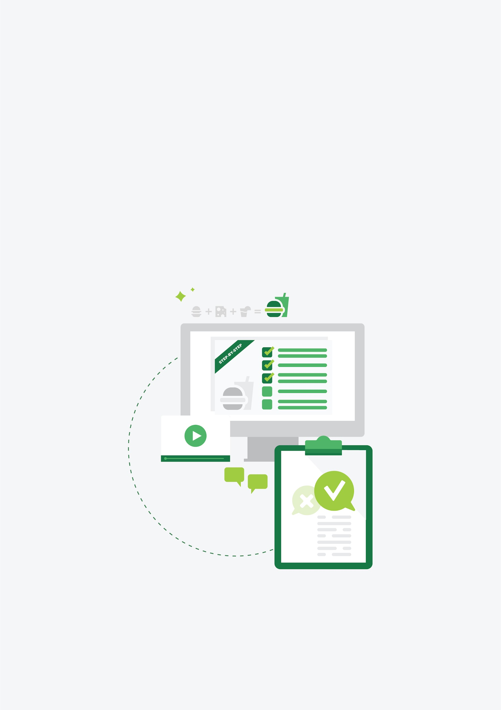

On-page SEO For Content Creation Knowledge Bank

Introduction/background

So it’s time to create your Step-By-Step Guide.

Contents

Introduction/background
Contents
Keyword research for content creation
Meta title and meta description writing
Heading format and structure
URL structure
Internal linking
Call to actions
External linking
Image optimisation
Best practice for key takeaways sections
Self-editing
Google search console submission

Fundamentals Of Keyword Research For Content Creation

Understanding how terms fit into the marketing funnel.
Before discussing how keywords fit within a marketing funnel, it’s important to provide a quick overview of the content marketing funnel as a whole.
The content marketing funnel represents the customer journey from initial discovery to becoming a loyal advocate. While different frameworks exist, they all describe a similar progression. Let’s break down two common models:
Traditional AIDA Model:
- Awareness - Customer becomes aware of your brand/product
- Interest - They show interest and want to learn more
- Desire - They develop a preference for your offering
- Action - They make a purchase or take the desired action
Modern 5-Stage Funnel:
- Awareness - Discovery of brand/problem
- Consideration - Research and evaluation
- Conversion - Making the purchase decision
- Loyalty - Repeat purchases and engagement
- Advocacy - Recommending to others
The key is that while the terminology and number of stages may vary, the fundamental concept remains consistent: guiding prospects through a journey from initial awareness to becoming customers and advocates. Each stage requires different types of content tailored to the audience's needs and intent at that point.
For the purposes of this section, let’s focus on a simplified 3 tier funnel:
- Top of Funnel (TOFO) - Educational content, blog posts, social media
- Middle of Funnel (MOFU) - Case studies, webinars, detailed guides
- Bottom of Funnel (BOFU) - Product demos, trials, consultation calls
Based on search intent, keywords will fall into these stages of the funnel. This will apply differently depending on the client but here are some general rules you can follow to find terms at different levels of the funnel:

Top of Funnel:
Search terms tend to be broad, informational queries that show users are trying to understand a problem or topic, often including words like "what is," "how to," "guide," or "tips".
These queries typically have higher search volume but lower conversion intent, as users are still in research/learning mode.
Questions and comparison terms are common, showing users trying to educate themselves about solutions.

Middle of Funnel:
Keywords become more specific and often include category or product type terms, showing users are aware of potential solutions but comparing options
Search terms frequently include words like "best," "top," "versus," "alternative," or "comparison," indicating evaluation behavior.
Users may include industry terminology, showing increased knowledge of the solution space.

Bottom of Funnel:
Highly specific terms often including brand names, product names, or location-specific modifiers that indicate ready-to-buy intent.
Keywords frequently include terms like "buy," "price," "cost," "near me," "demo," or "review," showing purchasing consideration.
Search volume tends to be lower, but conversion intent is much higher.
General examples
E-Commerce  Top of funnel  "how to choose running shoes"  "winter fashion trends 2025"  "differences between yoga mat materials"  Middle of funnel  "best lightweight running shoes"  "sustainable winter coat brands"  "cork vs rubber yoga mats"  Bottom of funnel  "Nike Air Zoom Pegasus 41 price"  "Patagonia winter coat sale"  "Manduka PRO yoga mat buy" | SaaS  Top of funnel  "what is project management"  "how to improve team productivity"  "remote work collaboration tips"  Middle of funnel  "best project management software"  "team productivity tools comparison"  "collaboration platform features"  Bottom of funnel  "Asana vs Monday.com pricing"  "Slack enterprise demo"  "Jira implementation cost" | Service based business  Top of funnel  "signs you need accounting help"  "benefits of professional landscaping"  "when to hire a marketing agency"  Middle of funnel  "small business accounting services"  "commercial landscaping companies"  "digital marketing agency specialties"  Bottom of funnel  "CPA firms near me"  "landscape design consultation cost"  "marketing agency proposal request"

Ahrefs breaks down a potential buyer’s journey with the objective of signing up for a paid plan, and keywords they could target at each level of the funnel.

Top Of Funnel (TOFU)
“Increase website traffic”

Middle Of Funnel (MOFU)
“SEO tools”

Bottom Of Funnel (BOFU)
“Ahrefs vs SEMRush”

Understanding search intent

Search Intent Categories (with examples):

- Informational: The user wants to learn about something
“How do motion sensors”, “benefits of practicing yoga”, “benefits of SSDs in laptops”, etc.
- Navigational: The user is trying to find a specific page or website
“Facebook login”, “Adobe tutorial”, “Dell website”, etc.
- Commercial: The user is researching options before making a purchase
“Best laptops for graphic design” “best office chairs under R5000”
- Transactional: The user wants to take an action like completing a purchase
“Buy MacBook Air M2” “virtual yoga classes sign up”

Methods for testing search intent

Google Searches
Understanding search intent is essential for effective keyword research, ensuring your content aligns with what users are looking for. One of the most effective ways to determine intent is by performing Google searches and analysing the results.

1. Analyze the Search Engine Results Page (SERP):
Perform a Google search for your target keyword and examine the top-ranking pages. The nature of these results provides clues about user intent:
- Informational Intent: If the SERP is populated with blog posts, how-to guides, or educational articles, users are likely seeking information.
- Commercial Intent: The presence of product reviews, comparison articles, or listicles suggests that users are evaluating options before making a purchase.
- Transactional Intent: Listings of product pages, e-commerce sites, or services indicate that users are ready to make a purchase or take a specific action.

2. Utilize Google's Autocomplete and Related Searches:
Begin typing your keyword into Google's search bar and observe the autocomplete suggestions. These suggestions reflect common queries related to your keyword and can reveal user intent. Additionally, at the bottom of the SERP, the "Related searches" section offers further insights into related topics and user interests.

3. Examine the "People Also Ask" Section:
This feature displays questions commonly associated with your search query. Analyzing these questions can help you understand the specific information users are seeking, allowing you to tailor your content to address these queries directly.

4. Assess SERP Features and Rich Results:
Pay attention to any rich results, such as featured snippets, image carousels, or video results. The presence of these features indicates the type of content that Google deems relevant for the query, providing further insight into user intent.

5. Conduct Competitor Analysis:
Review the content of top-ranking pages for your target keywords. Assess the format, depth, and angle of their content to determine how they are meeting user intent. This analysis can inform your strategy to create content that fulfills the same intent more effectively.
You can also copy the URLs of the top ranking results within site explorer in Ahrefs to give you an idea of the keywords a particular page/post is ranking for.

Ahrefs perspective and using Ahrefs keyword explorer

Ahrefs covers how to analyse search intent, referring to the three C’s of search intent:

- Content type refers to the dominant type of content you will see in SERPs, such as blog posts, landing pages, or product pages.
- Content format refers to the actual format - tutorials, reviews, comparisons, or list posts, for example - of the top-ranking pages for the desired keyword.
- Content angle refers to the unique selling point highlighted by the top-ranking pages in SERPs and tells you more about what users value the most when they type in a specific search query.

1. Utilizing Ahrefs' Keywords Explorer to Determine Search Intent:

Input Seed Keywords: Begin by entering your primary keywords into Ahrefs' Keywords Explorer. This will generate a comprehensive list of related keyword suggestions.

Analyze Keyword Attributes: Ahrefs tags keywords with specific intent labels—Informational, Navigational, Commercial, and Transactional—based on the nature of the search queries. These labels help you understand the underlying user intent.

2. Filtering Keywords by Search Intent:

Access the Intents Filter: Within Keywords Explorer, click on the "Intents" filter located at the top left. A drop-down menu will appear, displaying various keyword attributes you can filter by.

Select Desired Intents: Choose one or more intent categories—Informational, Navigational, Commercial, Transactional—to filter keywords that match the selected intents. This allows you to focus on keywords that align with your content goals.

An important note:
Do not rely completely on Ahrefs search intents feature. It’s best that you do manual Google searches in many cases. Ahrefs does not have data on search intents for every keyword. Even when requesting an update using the button.

Brainstorming keywords & exporting data
Refer to the dedicated keyword research for content creation SOP to follow the methodology used to brainstorm keywords within the keyword research template.

Remember to cover these bases when listing potential keywords:
- Singular & plural forms
- Common synonyms and closely related terms
- Spelling variations
- Industry recognised terms
- Intent focused terms
- Comparative keywords
- Brand specific terms
- Seasonal or temporal variations
- Negative keywords (to exclude from your list)

Define your base phrase and modifiers within the keyword research template.
Use the ranges A2:N19 (modifier + base phrase) and B20 to N95 (base phrase + modifier) to quickly brainstorm a list of terms.
Use the columns O and P to flatten terms within these respective ranges into a single column each. This will help you copy them into Ahrefs.

Meta title and meta description writing

Meta titles

Length
Most sources recommend writing meta titles that are between 50 to 70 characters in length.

Google typically truncates meta titles that are longer than 60 characters.

Google does not provide a recommended meta title length, only to keep title tags descriptive and concise.

Our content audit considers meta titles longer than 60 characters as being too long, and meta titles less than 25 characters are considered too short.

Aim for a meta title length of 60 characters or less.

- Sources:
  - Search Engine Journal
    - Moz: 50-60 characters
    - Ahrefs: 50-60 characters
    - SEMRush: 10- 70 characters
  - Backlinko: 40-60 characters.
  - Search Engine Land: 45-55 characters (not including the brand suffix).
  - RankMath: 50-60 characters.

Best practices for engagement

The best meta titles match search intent, incorporate the best keyword variation, are engaging/interesting and encourage a specific action.

Considerations
- Not longer than 60 characters. Be specific about what the page offers while remaining concise.
- Include the target keyword clearly (ensure you are targeting the best keyword variation possible)
- Incorporate action-oriented words or power words (will vary widely depending on the page or blog post). Have a look at “include power words” in this article from Ahrefs. These might include “Sign up”, “Buy”, “Book”.
- Make the meta title engaging.

Templates and examples

Generic template:
{Call to action word} + {Target keyword} + {Location/Additional Descriptor} + Separator | + {Site Title}

Example: Buy Gaming Laptops Online in South Africa | Brand

Ahrefs ABC formula:

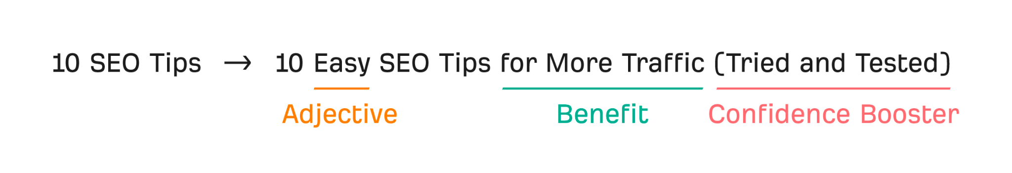

Meta descriptions

Length
Most sources recommend writing meta descriptions that are between 150 to 160 characters in length.

On desktop devices, Google typically truncates snippets at around 960 pixels which translates to approximately 152 characters.

On mobile devices, Google typically truncates meta descriptions at about 680 pixels, which equates to roughly 105 characters.

Our content audit consider meta descriptions longer than 140 characters to be too long, and consider meta descriptions less than 100 characters as being too short.

Aim for a meta description length of 120 - 140 characters.

- Sources:
  - Search Engine Land (150 - 160 characters)
  - Search Engine Journal (160 characters max for desktop; 120 characters max for mobile)
  - Backlinko (under 155 characters)
  - Yoast (roughly 155 characters)
  - RankMath (ideal length is 160 characters, recommend writing descriptions between 50-160 characters)

Best practices for writing meta descriptions
Elementor describes the purpose and intent behind a meta description well. “A great meta description does several things simultaneously:

- Provides a Snapshot: It gives users a quick understanding of what your page is about.
- Reflects Search Intent: It aligns with what the person searching is actually looking for.
- Entices Action: It uses persuasive language to encourage that click-through.”

Considerations
- Length: 120-140 characters.
- Keywords: Include your primary keyword and secondary ones if you can, naturally.
- Call to action: Use action-oriented words like “Buy”, “Shop”, “Explore”, “Discover”, “Learn”, “Join”, “Sign up”, “Get
- Tone of voice: Ensure the tone of the meta description matches the site’s brand voice.
- UVP: Show a user why they should choose your page by highlighting a unique value proposition.

Templates and examples

Generic:

{Introduce the page} + {mention examples of what’s offered by the page} + {call to action that includes brand name}

Example:

Generic product template from Shopify:

"Discover [Product/Service] that [solves a problem or provides a benefit]. Shop now to enjoy [unique selling proposition or offer]."

Example: "Discover our eco-friendly water bottles that keep your drinks cold for 24 hours. Shop now to enjoy free shipping on orders over $50!"

Generic E-Commerce Offer Template

"Shop our collection of [Product Category] with features like [key features]. Order now for [incentive, e.g., free shipping or discounts]."

Example: "Shop our collection of noise-cancelling headphones with premium sound and long battery life. Order now for free shipping!"

Informational template
Learn about [topic or service] and discover how it can help you [achieve a goal]. Read more to find out!"

Example: "Learn about effective link-building strategies and boost your website's traffic. Read our expert guide!"

Action-Oriented Template:
"Get [Product/Service] today and [actionable benefit]. Don’t miss out on [special offer or feature]."

Example: "Get the best hiking boots today and conquer any trail. Enjoy 20% off your first order!"

Heading format and structure
  - Readability and engagement
  - Hierarchy
  - Incorporating keywords

URL structure
  - Length
  - Keyword targeting
  - Subfolders

Internal linking
  - Relevancy/relevant content
  - Descriptive anchor text containing keywords
  - 3

Call to actions
  - Ideal placements inside blog posts.
  - Natural segues
  - 3

External linking
  - Cite authoritative sources: Link to high-quality, relevant, and trustworthy sites.
  - Open in a new tab: Ensure external links open in a new tab to retain user session on your site.
  - No-follow links for questionable sources: Use “no-follow” tags when linking to promotional or less trusted sites.

Image optimisation
  - Filenaming
  - Alt text
  - Compression/file size

Best practice for key takeaways sections
  - 1
  - 2
  - 3

Self editing
  - Use a checklist: Review for grammar, clarity, and structure using tools like Grammarly.
  - Read aloud: Reading your content aloud helps identify awkward phrasing or flow issues.
  - Focus on SEO: Check keyword placement, keyword density meta data, and internal links during editing.

Google search console submission
  - 1
  - 2
  - 3

